PROJECT ON SQL

TOPIC NAME :- PHONE SHOP

Made By :- Shruti Sahu

## 

**************CREATED TABLE USING CONSTRAINTS************

create table Phone_types(P_id int PRIMARY KEY,Brand_name varchar(50),Model_name varchar(50),Price double,

# Quantity int);

#insert into Phone_types VALUES (1,"Samsung","Galaxy_M04",8499,10),

# (2,"Samsung","Galaxy_M02",8199,5),

# (3,"Samsung","Galaxy_A02",10999,8),

# (4,"Samsung","Galaxy_A32",25000,8),

# (5,"Redmi","Mi_Note_8",15000,9),

# (6,"Redmi","Mi_Note_9",18000,10),

# (7,"Redmi","Mi_Note_10",20000,9),

# (8,"Redmi","Mi_Note_11",21000,10),

# (9,"Apple","IPhone_7",50000,3),

# (10,"Apple","IPhone_8",55000,5);

#select * from phone_types;

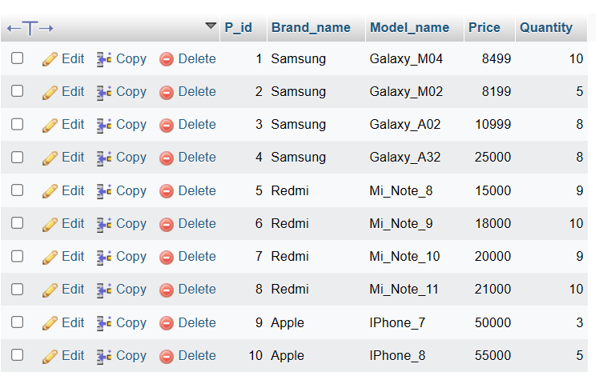

#create TABLE phone_details(P_id int, FOREIGN key(P_id)REFERENCES phone_types(P_id),CAMERA VARCHAR(50),MEMORY VARCHAR(50),RATINGS INT,Date_of_Launch date);

#nsert into phone_details values(1,"8MP","2GB",8,"20190505"),

# (2,"48MP","2GB",7,"20200321"),

# (3,"48MP","4GB",8,"20200813"),

# (4,"48MP","4GB",9,"20210215"),

# (5,"50MP","4GB",9.5,"20190814"),

# (6,"64MP","4GB",8.5,"20201219"),

# (7,"105MP","6GB",10,"20211015"),

# (8,"105MP","6GB",7.5,"20211219"),

# (9,"120MP","8GB",9,"20221225"),

# (10,"130MP","10GB",10,20230131);

#select * from phone_details;

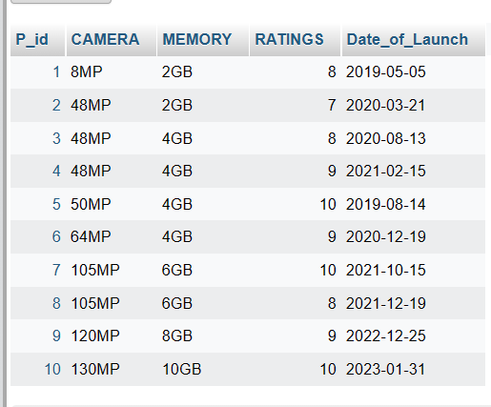

****************USE OF DISTINCT *****************

#SELECT DISTINCT Brand_name from phone_types;

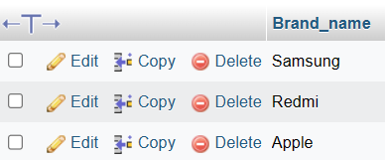

#select distinct MEMORY FROM phone_details;

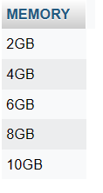

*************** USE OF WHERE ************

#select * from phone_types where Brand_name="Samsung";

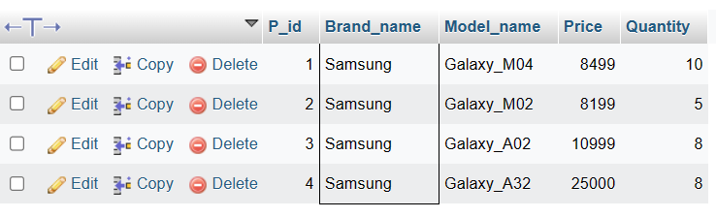

#SELECT * from phone_details where Date_of_Launch="20201219";

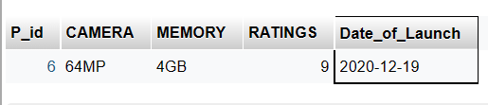

************* USE AND,OR,NOT ***************

#select * from phone_types where Model_name="Galaxy_A32" and Price="25000";

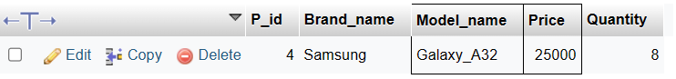

#select * from phone_details WHERE P_id="107" or MEMORY="6GB";

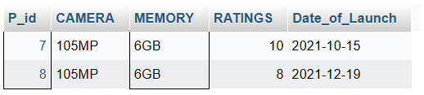

#select * from phone_types where NOT P_id="9";

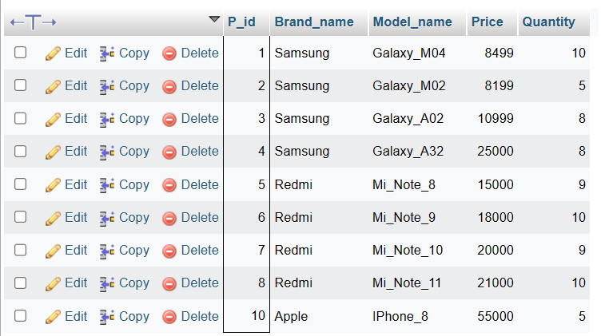

#select * from phone_types WHERE Brand_name="Apple" and (Model_name="IPhone_7" or Model_name="IPhone_8");

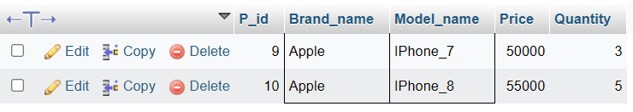

#select * from phone_details where not CAMERA="105MP" and not MEMORY="6GB";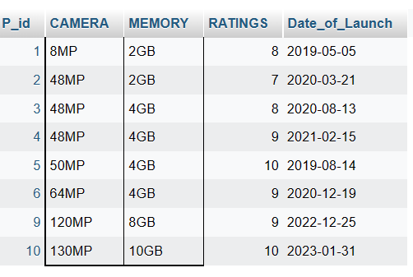

**************USE OF ORDER BY *******************

#select * from phone_types ORDER BY Brand_name;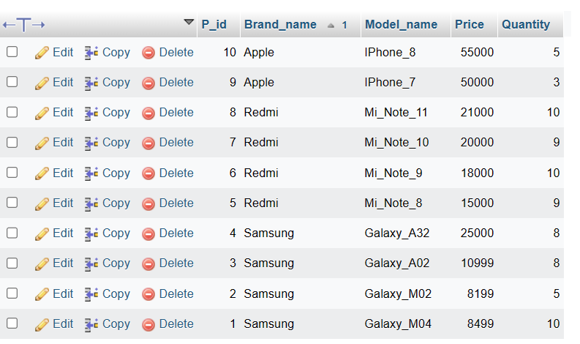

#select * from phone_types ORDER by Brand_name DESC;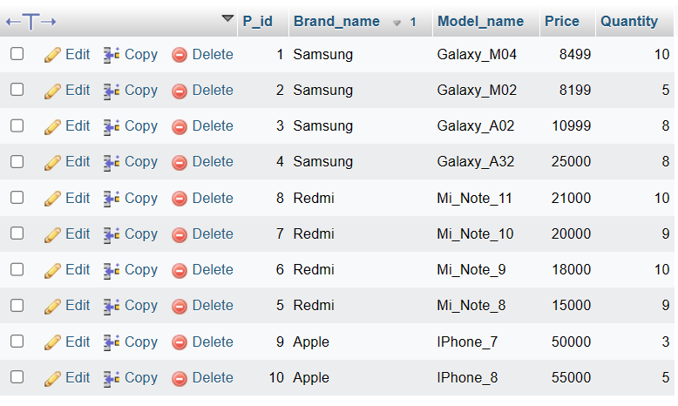

#select * from phone_types ORDER BY Brand_name,Model_name,P_id;

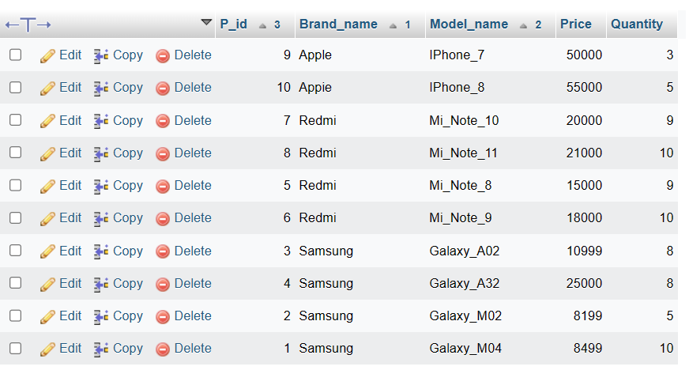

***********USE OF UPDATE **************

#UPDATE Phone_types SET Brand_name="1Plus", Model_name="1Plus_10" where P_id=4;

#SELECT *from Phone_types;

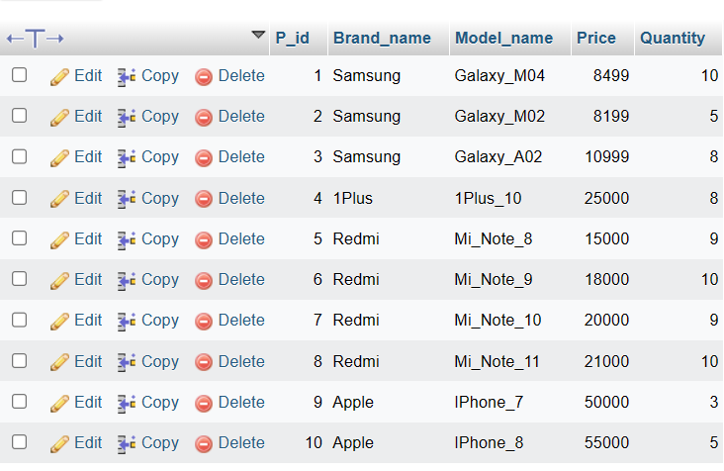

#UPDATE phone_details SET MEMORY="5GB" WHERE RATINGS="8";

#SELECT *from phone_details;

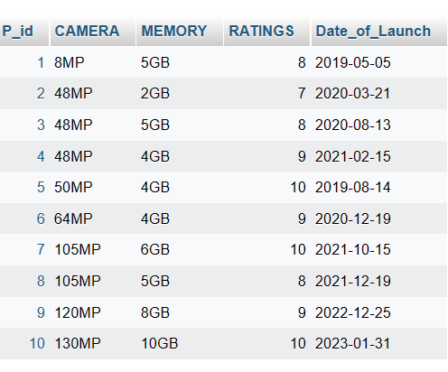

**********USE OF MIN & MAX FUNCTION ****************

#select min(Price),Brand_name from phone_types;

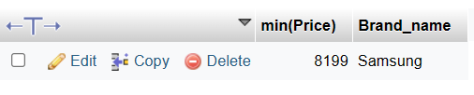

#select MAX(Price),Brand_name from phone_types;

******** USE OF COUNT, AVG & SUM FUNCTION **********

#select COUNT(Quantity) from phone_types;

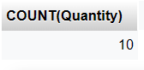

#select avg(Price) from phone_types;

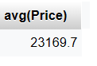

#select sum(Quantity) from phone_types;

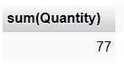

**************USE OF LIKE FUNCTION ****************

#select Brand_name from phone_types where Brand_name like "s%";

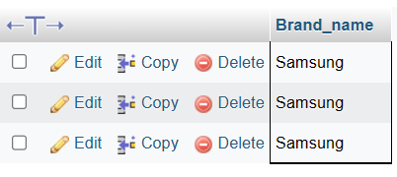

#select Brand_name from phone_types where Brand_name like "%A";

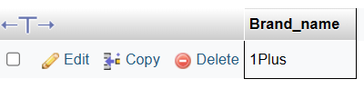

************IN OPERATOR ***************

#select * from phone_details where P_id not IN ("105");

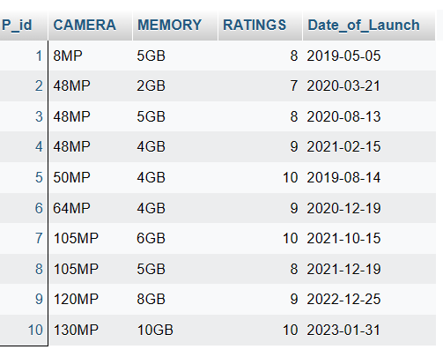

#select P_id from phone_types where P_id IN (1,2,3,4,5,6,10) ;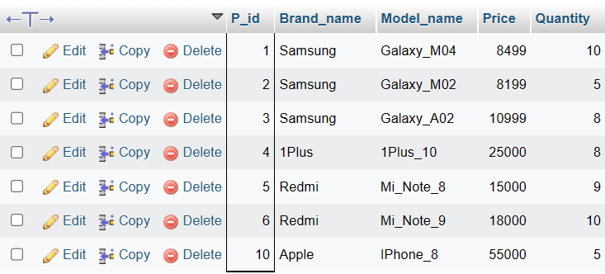

**************** BETWEEN OPERATOR *****************************

#select * from phone_types where Price BETWEEN 8000 and 15000;

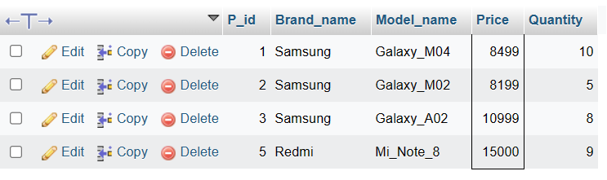

#SELECT * from phone_types where Price BETWEEN 8000 and 15000 and P_id not in(1,2,3);

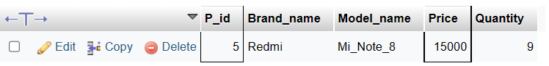

#select * from phone_types where Model_name BETWEEN "Galaxy_A02" and "IPhone_8" ORDER by Model_name;

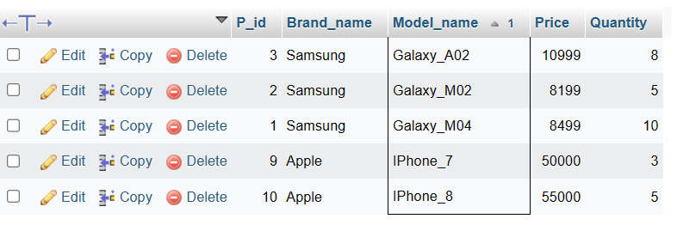

********************************** USE OF ALIASES ******************************

#select P_id as "Id",MEMORY as "STORAGE" from phone_details;

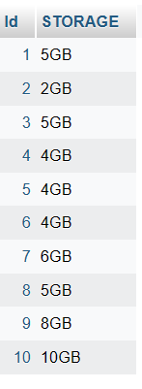

#SELECT Model_name as "MODEL",Brand_name as "BRAND" FROM phone_types;

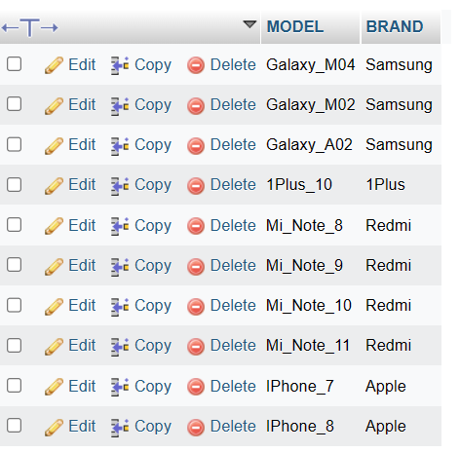

************* USE OF COMPARISON OPERATORS *******************************

#select Brand_name,Price from phone_types where Price>="15000";

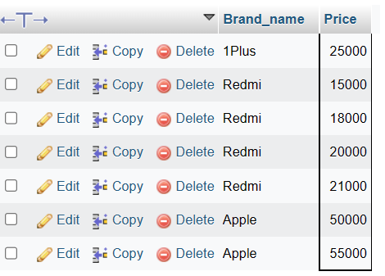

#select Brand_name,Price from phone_types where Price<="10000";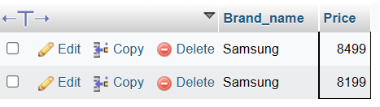

#SELECT Brand_name,Model_name from phone_types where Brand_name="Redmi";

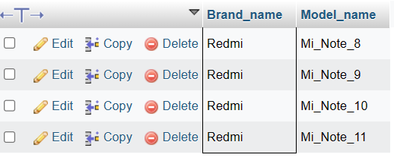

***************USING NULL & NOT NULL OPERATOR ******************************

#select CAMERA,MEMORY FROM phone_details where "RATINGS" is null;



#select CAMERA,MEMORY FROM phone_details where "RATINGS" is not null;

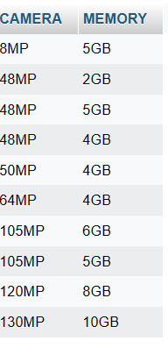

#select CAMERA,MEMORY FROM phone_details where "RATINGS" is not null and MEMORY="4GB";

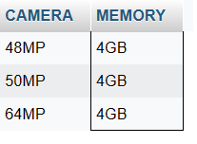

********************** STRING FUNCTIONS ******************

************* UPPER & LOWER **********************

#select UPPER("Samsung") as "Brand_name" from phone_types;

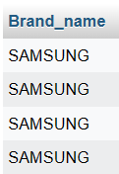

#select lower("Samsung") as "Brand_name"from phone_types;

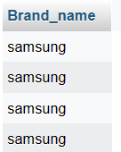

**************************** JOINS **************************

****************** INNER JOINS *******************

#SELECT phone_details.P_id,phone_types.Brand_name FROM phone_details INNER JOIN phone_types ON phone_details.P_id=phone_types.P_id;

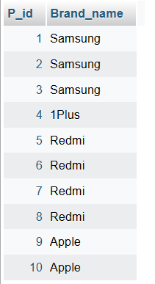

******************* LEFT JOINS ***************

#select phone_details.CAMERA,phone_types.P_id FROM phone_details LEFT JOIN phone_types ON phone_details.P_id=phone_types.P_id order BY phone_details.CAMERA;

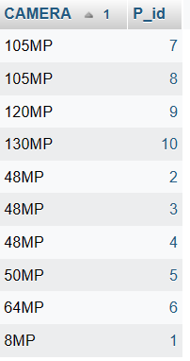

******************* RIGHT JOINS **************

#select phone_types.Model_name,phone_details.P_id from phone_types RIGHT JOIN phone_details ON phone_types.P_id=phone_details.P_id ORDER by phone_types.Model_name;

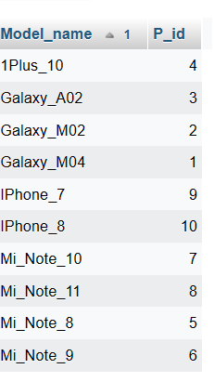

***************** SUB-QUERY *************

#SELECT Price from phone_types where price=(SELECT max(Price) from phone_types);

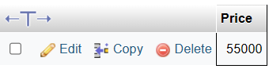

#select Price,Brand_name,Model_name from phone_types where Price>(select Price from phone_types where P_id=3);

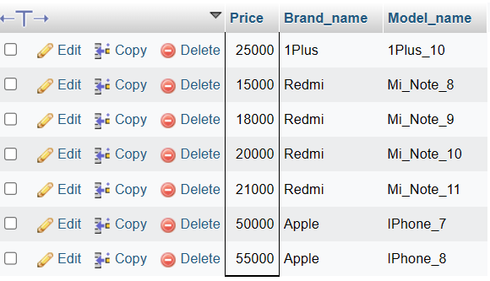

******************* VIEWS **************

#create VIEW Phone_view as SELECT P_id,Brand_name,Model_name,Price,Quantity FROM phone_types where Brand_name='Samsung';

#SELECT * from phone_view;

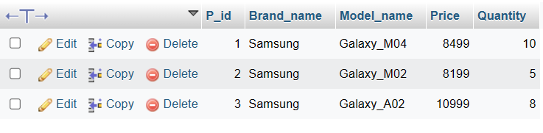

*************** DROP & DELETE ***************

alter table phone_types drop Quantity;

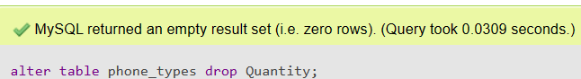

drop table phone_details;

